

Unit 1: Programming

Assignment1: Analysis on Algorithms

And Programming Paradigms

|  |
| --- |
| Zwe Hset Naing  HND 29 Batch  Youth International University |

Contents

P1. An algorithm and outline the process in building an application. 3

Algorithms 3

Simple Algorithms 3

Types of Algorithms 3

Quick Sort 5

How it works 5

Benefits of Quicksort 5

Process Stages of Building an application 6

P2. The steps taken from writing code to execution. 8

Implementation 8

Testing 8

Release 8

P3. Procedural, Object-orientated and Event-driven paradigms are their characteristics and the relationship between them. 9

Programming Paradigm 9

Procedural Programming 9

Object-orientated Programming 9

Event-driven Programming 10

Relationship between PP, OOP and EDP 10

M1. The process of writing code, including the potential challenges faced. 11

The Process of writing code 11

The facing with Potential Challenges 12

M2. The procedural, object-orientated and event-driven paradigms used in given source code of an application. 13

1. Declare header, function and variable 13

2. Display menu 15

3. Display classes 16

4. Enroll classes 17

5. Display days 18

6. Display Fees 19

7. Reuse (Not in some style) 19

D1. The implementation of an algorithm in a suitable language and the relationship between the written algorithm and the implemented code 21

The algorithms of quicksort in C++ 21

The relationship between the written algorithm and the implemented code 21

D2. Evaluation of the source code of an application that implements the procedural, object-orientated and event-driven paradigms, in terms of the code structure and characteristics. 25

Evaluation of the system 25

New Functions of Online Music Class System 25

# P1. An algorithm and outline the process in building an application.

## Algorithms

Algorithms are systematic methods or collections of guidelines for resolving certain issues or carrying out specific tasks. They are utilized in many domains, such as engineering, math, analysis of data, and artificial intelligence, and they create the foundation of computer science.

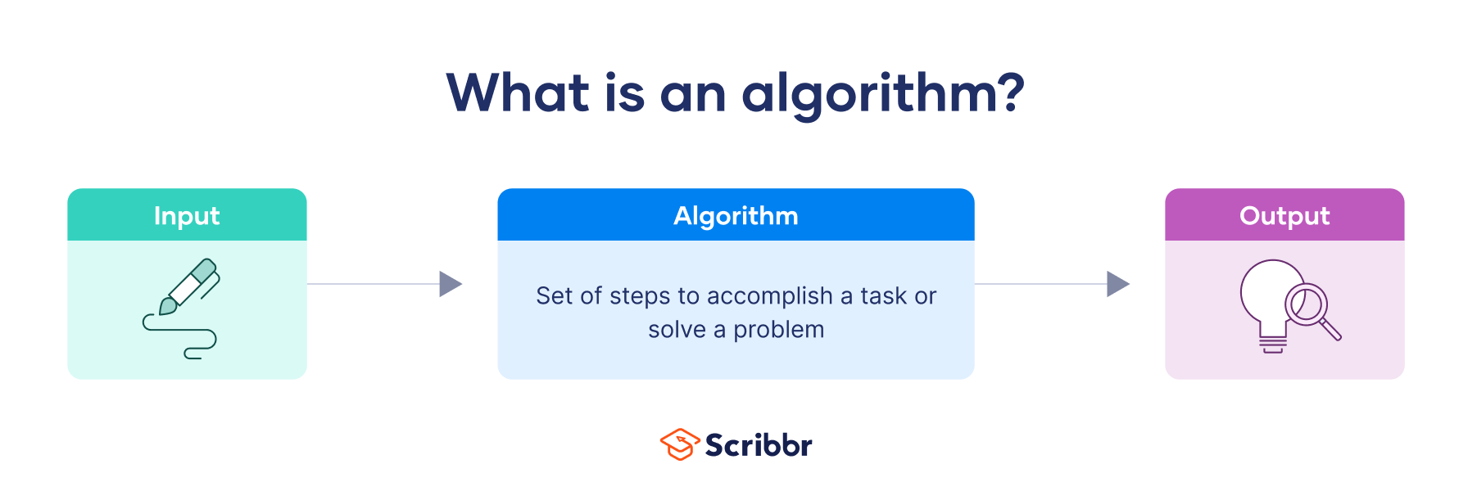

Fig.1.1. Algorithms

## Simple Algorithms

The following algorithms is to play music from Bluetooth air pod. It includes 6 stages.

Algorithms:

1.Open the phone

2.Tap the Bluetooth icon to enable Bluetooth

3.Find the Bluetooth air pod device on Bluetooth scan

4.Put the Bluetooth air pod to the ears

5.Open the music app at the phone

6.Start play the music

## Types of Algorithms

There are a lot of algorithms but mainly use sorting and searching.

Sorting

Sorting algorithms are crucial tools for numerical or lexicographical data organization, where data must be arranged in a particular order. Depending on the situation and needs, these algorithms offer different decisions in terms of efficiency and methodology.

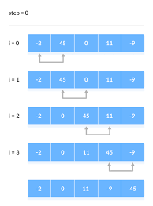

Fig1.2. Sorting

Example

Bubble Sort

Insertion Sort

Selection Sort

Merge Sort

Quick Sort

Searching

Algorithms for searching are essential tools for effectively locating particular items in a dataset.

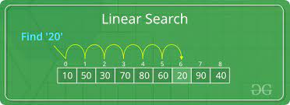

Fig1.3. Searching

Example

Linear Search

Binary Search

## Quick Sort

An effective general-purpose sorting algorithm is called Quicksort. The divide-and-conquer method is used in quicksort. To operate, one 'pivot' element is chosen from the array, and the remaining elements are divided into two sub-arrays based on whether they are bigger or less than the pivot.

## How it works

One important quicksort process is a partition. The goal of partitioning is to arrange the items in the sorted array so that the pivot is in the correct spot, with all smaller elements to the left of the pivot and all larger elements to the right of the pivot.

After the pivot is positioned correctly, partitioning is done recursively on either side of the pivot, which ultimately sorts the array.

## Benefits of Quicksort

|  |  |
| --- | --- |
| Quick Sorting Speed | Quick Sort's quick sorting speed is one of its main advantages. Quick Sort is known for its speedy sorting of big datasets. |
| Low Memory Usage | An additional benefit of Quick Sort is that it uses no additional memory because it is a stationary sorting algorithm, meaning that no additional memory is needed to sort the data. |
| Simple to build | In comparison to other sorting algorithms, Quick Sort is also comparatively simple to build. The algorithm takes an easy-to-understand and apply divide-and-conquer strategy. |

## Process Stages of Building an application

At the stages of building an application, there are 6 types in process. That are

1. Planning
2. Design
3. Development
4. Testing
5. Release
6. Maintenance

1.Planing

Planning should start as soon as you have an idea for an app in your head. planning does not mean determining the design or programming of your application.

2.Design

We will simply touch on a few of the most crucial elements of the app development process's many components during the design phase. First, the accepted wireframes need to be further refined by your UX and UI designers.

3.Development

The final version of the app's code is really written during the development stage. You use the wireframes' comments to help you make some final, maybe significant decisions.

4.Testing

Testing takes place together with the development phase. To minimize post-release expenses, testing must be done continuously. It is essential to do unit, UI, and integration tests to make sure that any significant errors are fixed.

5.Release

You will submit your application for approval to the Play Store or App Store. It's crucial to understand this process because you'll need to do it each time you issue an update for the app.

6.Maintenance

This phase actually starts at the same time as the release and need to go hand in hand. During maintenance, you keep an eye on your app's performance, address any bugs, and ensure that it keeps functioning as it should.

# P2. The steps taken from writing code to execution.

At the beginning of the development of the application, develop team need plan and design to write code. There are some stages such as implementation, testing and release.

## Implementation

At the first stage of the development is implementation stage. It stage serve from the simple writing code to the usable writing code. At this stage, the development team need professional programmers to work properly. The stages under the implementation stage are writing algorithms, writing code and editing and fixing.

Writing algorithms

At that stage, developers write algorithms to use easily write codes. Algorithms is a document that include the way to write code easier. For example, the direction guide at zoo can help the visitors. Same like that, algorithms will help developers how to write.

Writing code

After that stage, developers start write the code. Developers use algorithms when writing code. When writing code, the stages will write one by one.

Editing and Fixing

After the writing code is finished, developers check the code to perfect. If the error may occur, developers may fix it.

## Testing

When the system is finish and ready to use, the developer test themselves or publish test version to the user. At that stage, the developer needs to collect the feedback from the user. Some error or issues can find as the final problem. If the test version is perfect to use, the developer will go to next stage.

## Release

When the system is ready to use and perfect, the developer will release the system to the user. There will be 2 stages in that. After the developer release the system, the user need guide for using easily. Thus, developer need to prepare the documentation about update phases and guides. Another stage is maintaining. The developer needs to check the system daily or monthly because of unknown issues, hacking or delay on the system. If the developers check the system, issues and other bad things can be fix.

# P3. Procedural, Object-orientated and Event-driven paradigms are their characteristics and the relationship between them.

## Programming Paradigm

A method of arranging and understanding the execution of a computer's program that is comparatively high level is called a programming paradigm. One or more paradigms can be supported by a programming language.

## Procedural Programming

Programming under the imperative paradigm, procedural programming involves presenting a computer program's activity as a sequence of calling procedures (also known as functions or procedures).

Features and Characteristics

Sequence control, flexibility, execution control, and standard data structures are some of the properties of programming paradigms. The code is arranged into functions or procedures that can be called and carried out in a particular order. Because the program is executed in from the top down, it begins with the first instruction and works its way through the list of instructions. Data is stored and manipulated using variables, and the execution flow is managed by using control structures like loops and conditionals.

## Object-orientated Programming

A computer programming paradigm known as object-oriented programming (OOP) arranges the design of software around data or objects as opposed to functions and logic. Any data field with distinct properties and behaviors can be considered an object.

Features and Characteristics

The definition of classes is the next feature of object-oriented programming. The design plan for an object exists in a class. The object's properties, methods, and other details are specified in the design. Classes are used to build objects. It outlines the object's characteristics, operations, and other elements.

## Event-driven Programming

The most common paradigm in network servers and applications with graphical user interfaces is event-driven programming. An event loop is typically present in an event-driven application, listening for events and triggering a callback function upon detection of one.

Features and Characteristics

One essential component of event-driven programming, which is used to create programs for services, is a focus on service. Time-driven programming is a paradigm in event-driven programming that refers to code that executes on a time trigger. It can also refer to specific code that executes at a given time.

## Relationship between PP, OOP and EDP

|  |  |  |  |
| --- | --- | --- | --- |
|  | Procedural Programming | Object-orientated Programming | Event-driven Programming |
| Paradigm Focus | focuses on creating functions or processes that work with data.  Programs are composed of a series of instructions that run continuously. | focuses on representing things from the real world as objects with information (characteristics) and behavior (methods).  The building blocks of programs are things that communicate with one another through sending messages. | focuses on reacting to user input or events.  Programs are designed with listeners or event handlers at their core, who watch for events and react to them. |
| Error Handling | Typically, global variables or return codes are used for error management. | supports the use of objects which include error handling and exceptions. | often uses event-driven error management techniques, including error event handlers. |
| Example of usage | scripts and basic command-line utilities. | Games, simulations, and GUI apps. | Games with an event-driven user interface, Web apps, and GUI apps. |

# M1. The process of writing code, including the potential challenges faced.

## The Process of writing code

Writing code is the important stage in the development of system. Developer may work carefully in that stage. If developer work carefully, the system will finish easily. If not, developer may fix it until perfect.



Fig 4.1. The process of writing code

There are many stages in that process such as

* set up the development environment
* writing algorithms or pseudocode
* writing session and
* testing

Set up the development environment

When the developer starts to develop a system or application, the developer needs an environment that is set up with all necessary tools and devices.

Writing algorithms or pseudocode

Before the coding process, the developer writes algorithms or pseudocode at first. Algorithms is a document that include the way to write code easier. For example, the direction guide at park can help the visitors. Same like that, algorithms will help developers how to write step by step.

Pseudocode is the document that include text and code. Same with algorithms, it can effectively help the developer.

Writing Session

There will be many languages can be used for programmer such as

* C
* Java
* C++
* C#
* Python and etc.

The task in that stage is writing code perfectly using algorithms or pseudocode. The developer may write the code with meaningful variable and function names. Because well-written code is its readability and understanding. The use of relevant variables and function names is a major component in making your code readable. Another fact is developer write comment in the code. It can make the developer to understand more when look back. That all fact can help developer when the developer found error or issues. The developer can fix it easily.

Testing

The developer will either test the system themselves or release a test version to the user once it is complete and operational. The developer must then get user input at that point. The ultimate issue may be certain mistakes or problems. The developer will go on to the next phase if the test version is flawless for usage.

## The facing with Potential Challenges

While developing code and proceeding toward execution, developers may run across a number of difficulties.

Time Limitations

Developers may have to operate under pressure to meet deadlines, which might affect the quality of their code and their comprehensive testing.

Problem Complexity

Complex problems which can be challenging to write perfectly may difficult to developer. Developer may need advanced algorithms and data structure.

Identifying and fixing bugs

It might take a lot of effort and advanced testing abilities to identify and correct flaws and problems in the code.

Teamwork

Working in a group, particularly in isolated or remote teams, can provide coordination and communication difficulties.

Testing Complexity

It may be difficult to correctly test code, especially in complex systems with plenty of interdependent components. This includes unit testing, integration testing, and system testing.

# M2. The procedural, object-orientated and event-driven paradigms used in given source code of an application.

The code of online music class application can write with PP, OOP and EDP style. There are many stages in application process. That will be 6 or 7 stages such as

1. Declare header, function and variable
2. Display menu
3. Display classes
4. Enroll classes
5. Display days
6. Display Fees and
7. Reuse (Not in some style)

## Declare header, function and variable

PP code for this stage

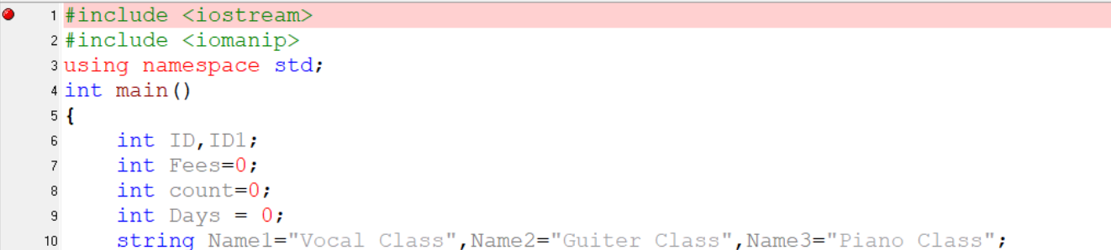

At the style of PP, the developer declares the header and function to write the program because that are fundamental need. In main function, the developer declares ID, ID1, Fees, count and Days in integer form and initialize to Name1, Name2 and Name3 in string Form.

OOP code for this stage

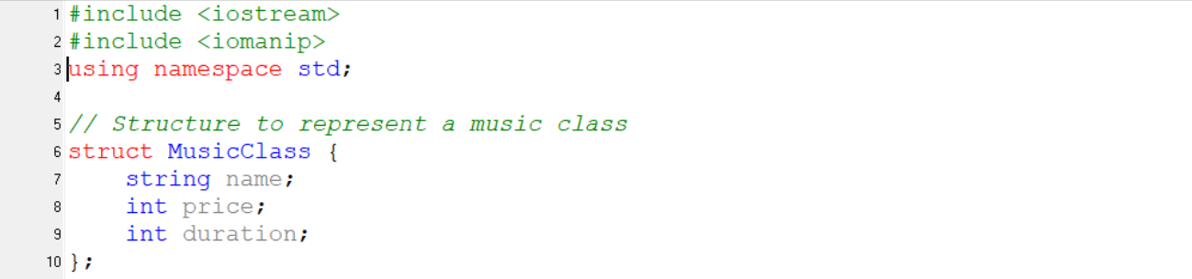

Same as PP style, the developer declares header and function. At OOP style, the developer build structure called MusicClass which has name, price and duration in integer and string form,

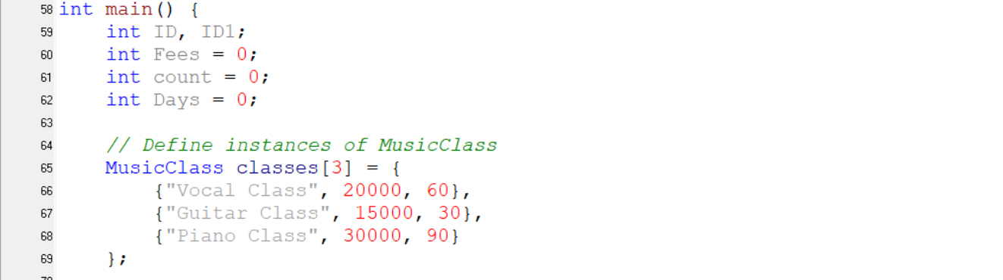

EDP code for this stage

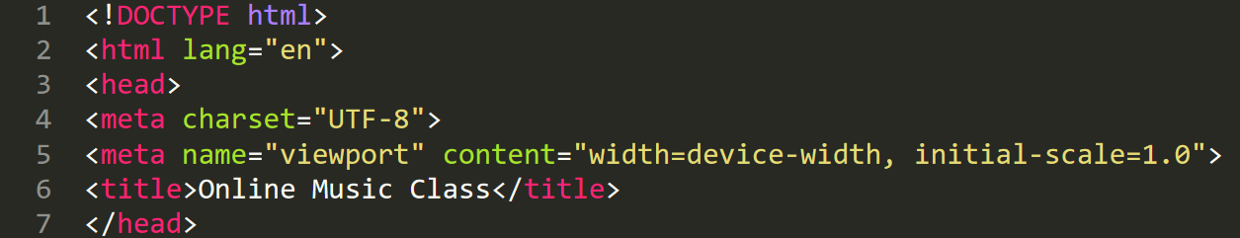

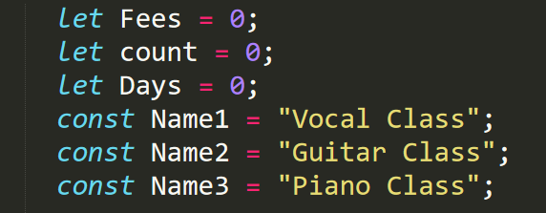

Same as PP and OOP, EDP also need to declare important code. At EDP style, the developer writes in HTML. In HTML, the developer can name the title. And then the developer declares the variable.

## Display menu

PP code for this stage

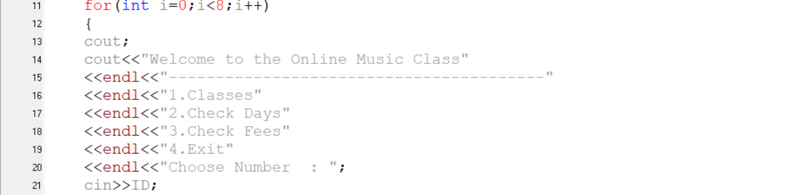

At this stage, the developer build “for” looping to display the menu. At menu, the user can choose option.

OOP code for this stage

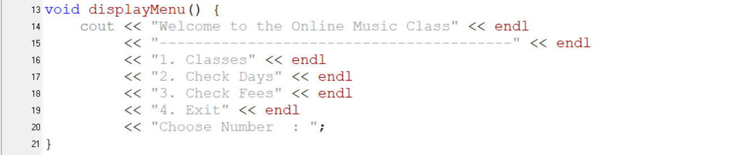

In OOP style, the developer builds the function called displayMenu. This function includes the display of menu list. In that menu, the user can choose the option what the user need.

EDP code for this stage

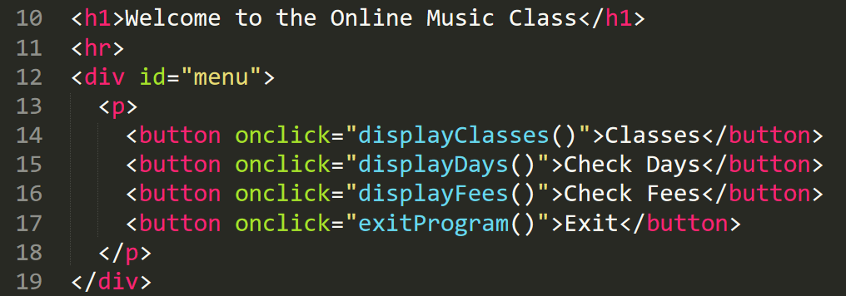

In EDP style, the developer writes the title with “h1” command. And then the developer call “div” command to show menu to user.

## Display classes

PP code for this stage

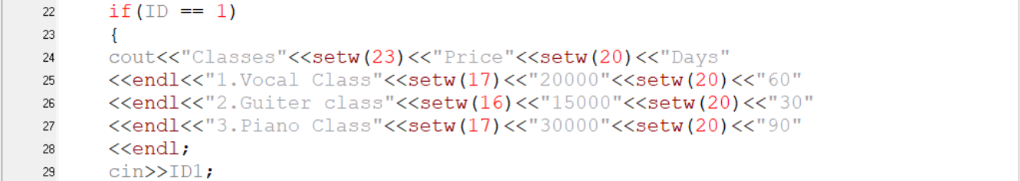

In this stage, the developer writes “if” to show class with table to the user. This table include classes name, price and days.

OOP code for this stage

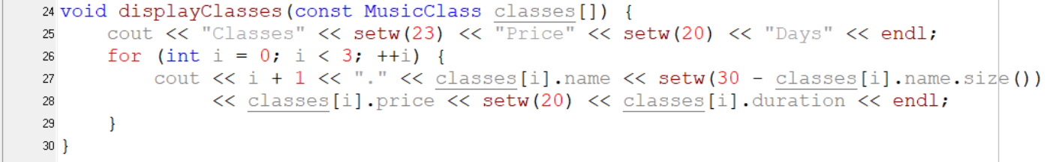

In OOP style, the developer builds the function called displayClasses. In this function, for looping is included. This looping act to show the classes table about class name, price and days.

EDP code for this stage

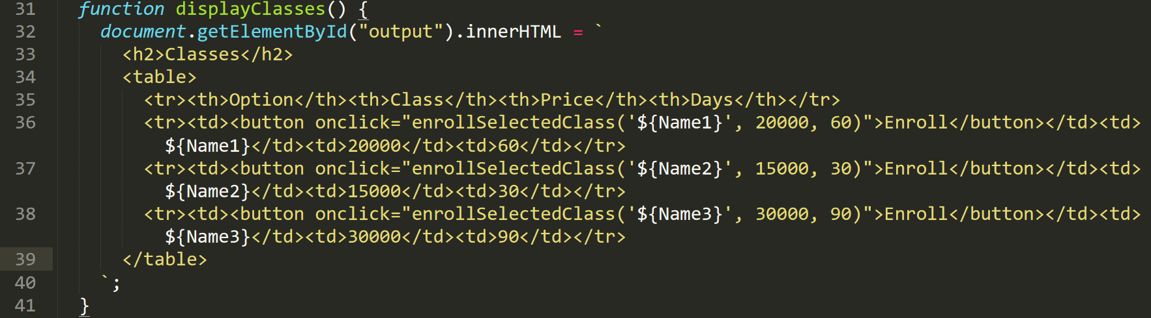

In EDP style, the developer write function to show the class table that includes class name, price and days. The developer use table, tr, td commands.

## Enroll classes

PP code for this stage

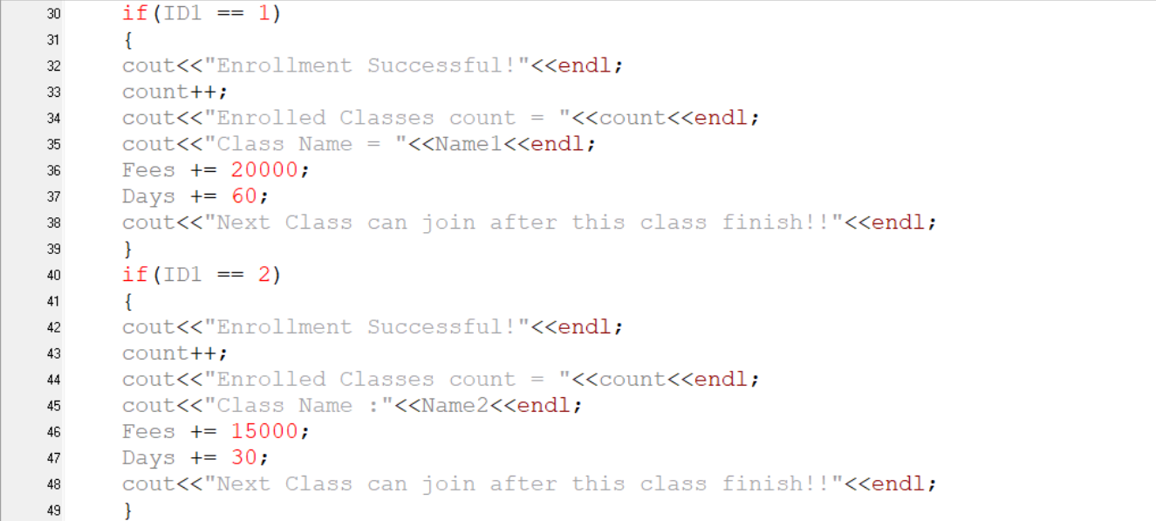

In enrollment, the developer checks the enroll list with “if”. For example, if the user chooses “1”, the vocal class will enroll. Like that, if the user chooses the number, relevant class will enroll.

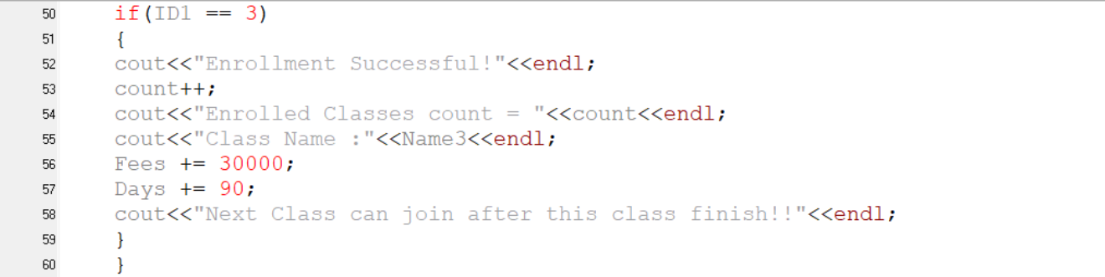

OOP code for this stage

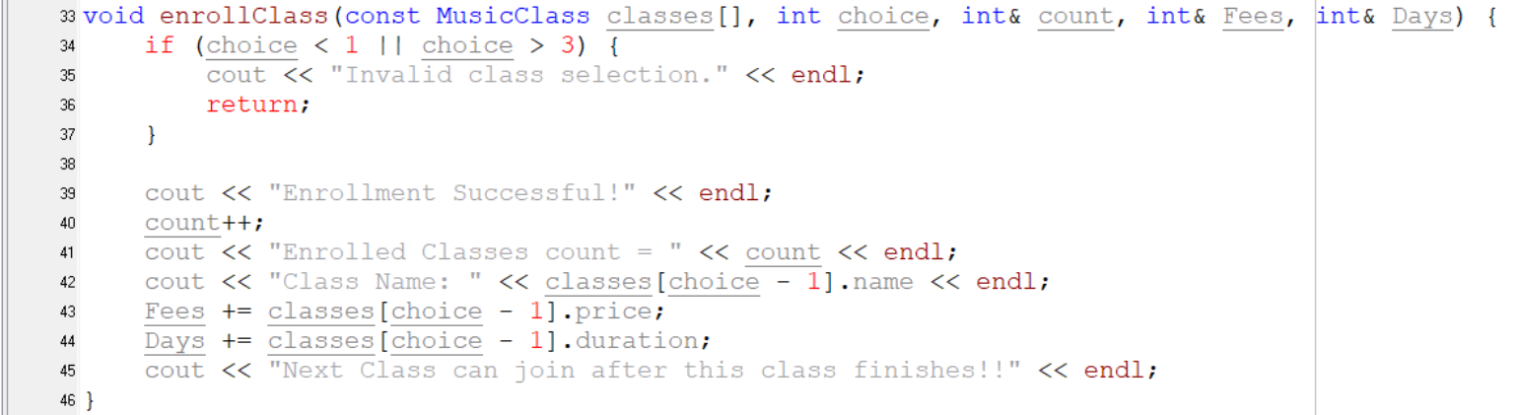

In OOP style, the developer build enroll function with “if” to check which class is user’s choice.

EDP code for this stage

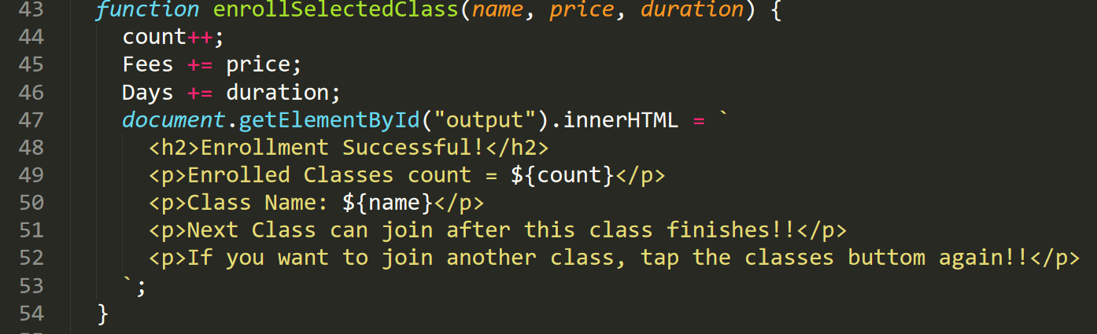

Same as OOP, the developer write function to enroll the user to class. In EDP, the developer requests the choice to enroll to each class.

## Display days

PP code for this stage



In this stage, if the user option 2, the duration will show.

OOP code for this stage



In OOP style, the developer builds the function called displayDays to display the duration.

EDP code for this stage

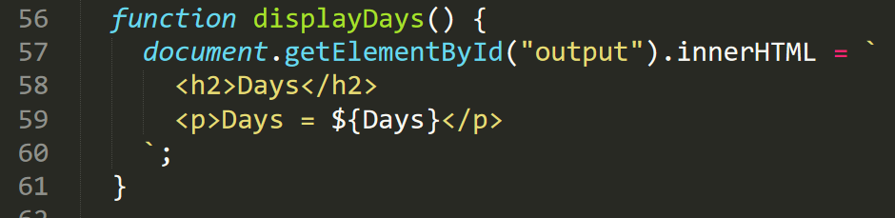

In EDP style, that function is simple to show. That function act to display the duration.

## Display Fees

PP code for this stage



In final stage of PP, that is simple function to show the final fees.

OOP code for this stage



In OOP style, the developer builds the function named displayFees to display the final fees.

EDP code for this stage

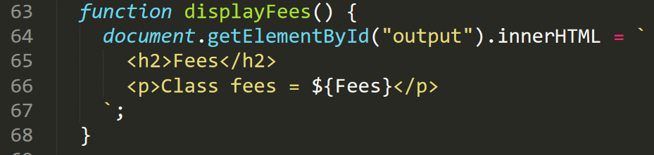

Same as PP and OOP, the developer writes displayfees to display the final fees.

## Reuse (Not in some style)

OOP code for this stage

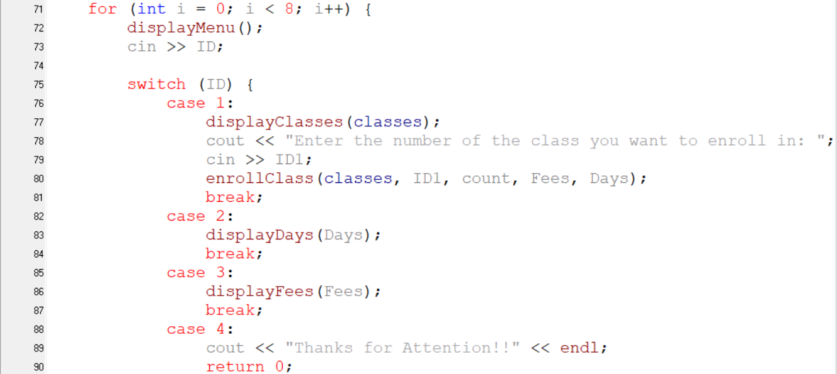

This stage is not included in PP and EDP. In this stage, the developer reuses the built functions in for looping. Reuse functions are displayMenu, displayClasses, enrollClass, displayDays and displayFees.

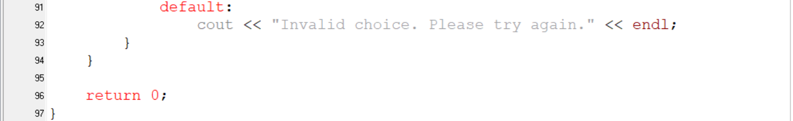

# D1. The implementation of an algorithm in a suitable language and the relationship between the written algorithm and the implemented code

## The algorithms of quicksort in C++

One of the most popular and effective sorting algorithms in computer science is quicksort. Its ability to use the divide-and-conquer strategy to sort massive datasets very quickly is what makes it so popular. The three main parts of the algorithm's fundamental examine are splitting the array, sorting sub-arrays recursively, and merging the sorted sub-arrays.

During the splitting step, the array is split into two sub-arrays depending on items bigger and smaller than the pivot when a pivot element is chosen.

After that stage, the sorting stage start. At first, the system picks one number to compare with others in each split array. And then, that number is placed in correct number. Same like that number, all numbers are sorted in each split array.

In the final Stage, the splitt5t arrays are merged together. At the final result. the array is correctly sorted from smaller to larger.

## The relationship between the written algorithm and the implemented code

The implementing code and the written algorithms’ relationship has five stages such as

1. Header and namespace declaration and swap function
2. Partition function
3. Quicksort function
4. Print array function and
5. Main function

1.Header and namespace declaration and swap function

Implemented code of this stage

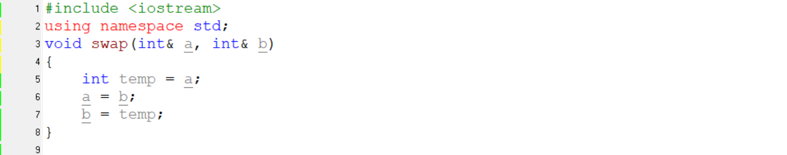

Algorithms of this stage

1. Declare header and namespace
2. Build the swap function

Relationship between algorithms and code of this stage

At first the developer declares the header and namespace. And then developer build swap function. The swap function uses a temporary variable called temp to swap the values of two integers.

2.Partition function

Implemented code of this stage

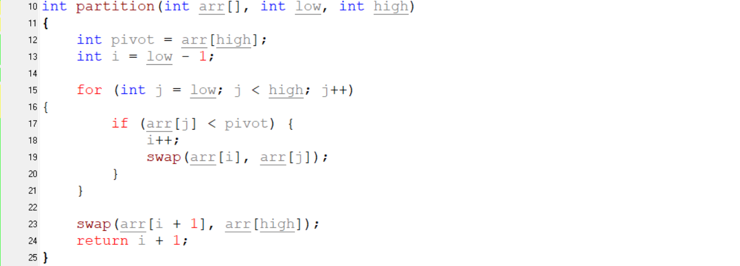

Algorithms of this stage

1. Build partition function
2. Build “for” looping from low until high in partition function
3. If arr[j] is lower than pivot then increase the i to 1 and use arr[i] and arr[j] in swap function under the “for” looping.
4. Use swap function with arr[i+1] and arr[high]
5. Call return to i+1

Relationship between algorithms and code of this stage

At this stage, the developer build partition with using “for” looping and if. The partition function is used to divide the array into two arrays which are bigger than pivot and smaller than pivot.

3.Quicksort function

Implemented code of this stage

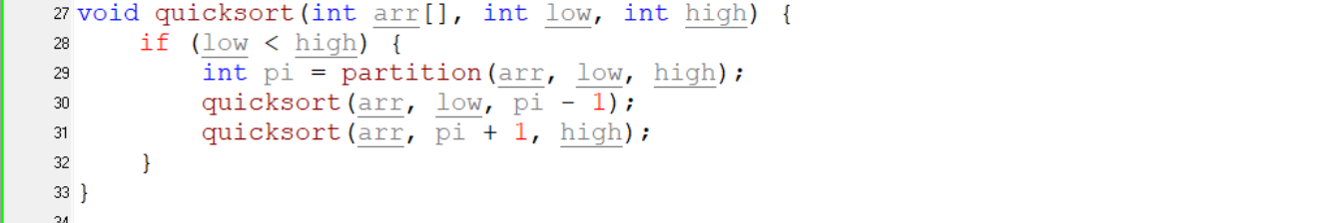

Algorithms of this stage

1. Build quicksort function
2. If “low” lower than “high” then

Relationship between algorithms and code of this stage

At this stage, the developer build quicksort function. The quicksort function is used to arrange the integer from smaller to larger. At this function, the function use partition and quicksort functions.

4.Print array function and

Implemented code of this stage

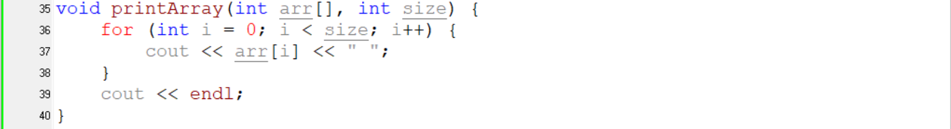

Algorithms of this stage

1. Build printArray
2. Build “for” looping from “I” until “size”.

Relationship between algorithms and code of this stage

The developer build printArray function using “for” looping. The printArray is used to show the array.

5.Main function

Implemented code of this stage

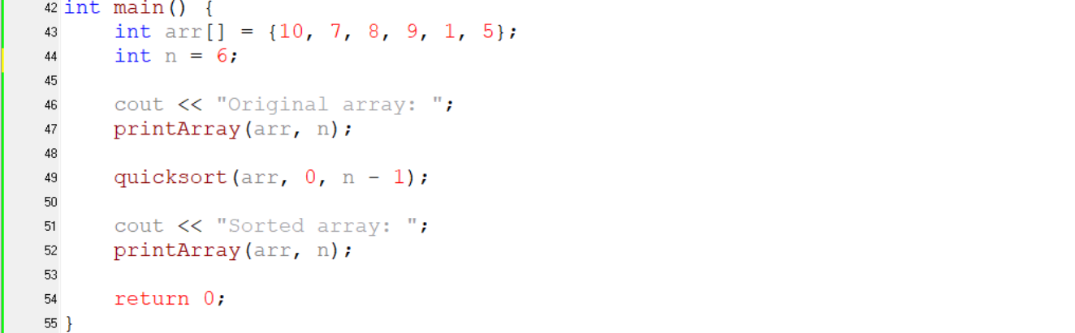

Algorithms of this stage

1. Declare main function
2. Declare array in integer form and initialize it
3. Declare “n” assign 6 in integer form
4. Show original array with printArray function
5. Use quicksort function
6. Show Sorted array with printArray function

Relationship between algorithms and code of this stage

At the final stage, the developer declare array in integer form and initialize it. The developer assigns constant value “6” into “n”. After that, the developer use printArray to show the original array. And then the developer use quicksort to sort the integers from the array. At the final task, the developer use printArray to show the sorted array.

# D2. Evaluation of the source code of an application that implements the procedural, object-orientated and event-driven paradigms, in terms of the code structure and characteristics.

## Evaluation of the system

Evaluation or upgrading for the system is required when the system is focus on long term. At the evaluation stage, the developer check the user’s needs and requests how to upgrade the system more flexible. For example the customer want to buy a milk but there is no milk in that market. And the customer requests the milk to the shopkeeper. If the shopkeeper want to upgrade or fill the user’s request, the shopkeeper will put the milk as a new item. Like that, the developer will upgrade the system for user’s needs.

## New Functions of Online Music Class System

When the developer evaluate the system, the developer put three new options for the system. That are

1. To display class teacher’s details
2. The function for online learners
3. The most flexible payment system

The first step of evaluation is displayed the class teacher details to the user. For some situation , the user want to know who will teach them like famous singers ,writers or artists. For another situation, the user choose the teacher who they want. Thus the developer put that function as new.

The second step of evaluation is the function for online learners. If the user can’t come to campus, the developer put new function for them. In this system, this function is free to use.

This function include four options such as

1. Access learning materials
2. View progress
3. Submit assignments
4. Take quiz

At the access learning materials option, the user can learn about music from online. At view progress option, the user can check what progress they attending. At submit assignments option, the user can do the lessons as the assignments. At take quiz option, the user can answer the quiz about the problem with no pressure.

The final step of evaluation is the payment function. This function is already added in the old version. But the new version of payment will be more flexible.

## To display the class teacher’s details

PP code for this function

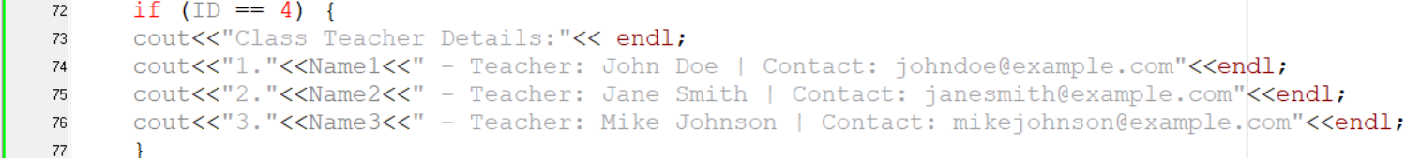

At the style of PP, the developer write the function in the written looping code. At this stage, the developer write the system to show the teacher’s details of each class.

OOP code for this function

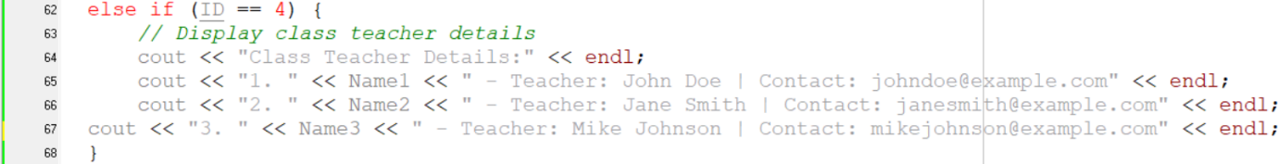

At the style of OOP, the developer write the function in the written looping code. OOP is different with PP because the developer write the new system outside the main function.

EDP code for this function

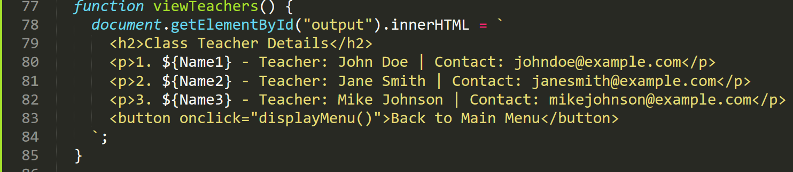

In EDP’s style, the developer add the new function in the written html code. In the code, the developer use the function keyword to show the teacher’s detail of each class.

## Online Learning System

PP code for this function

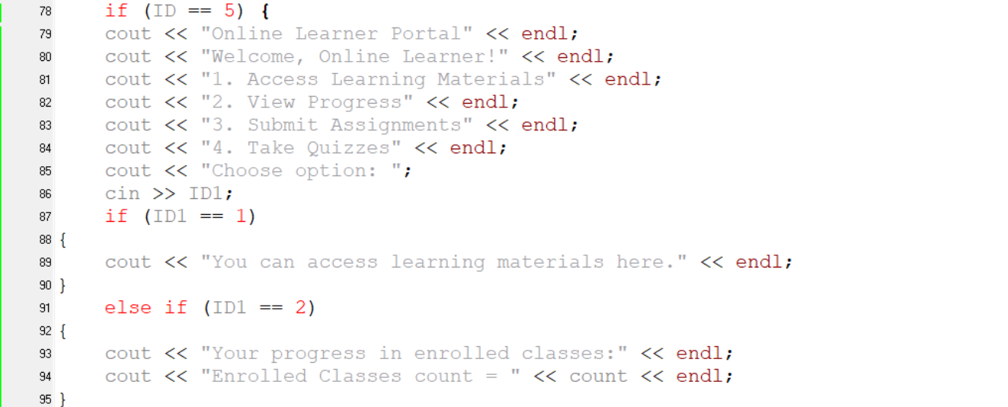

In the style of PP, the developer add the new function with loop. The code will be large because of four options. The developer write the four option with “if” keyword. For example, if the user choose number 1, the system will show learning materials. For number 2, the system will show progress. Like that each number are work with “if” keyword.

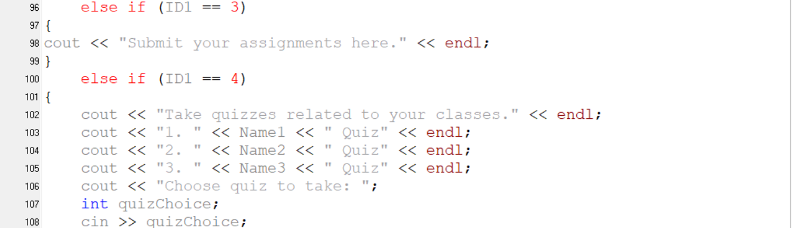

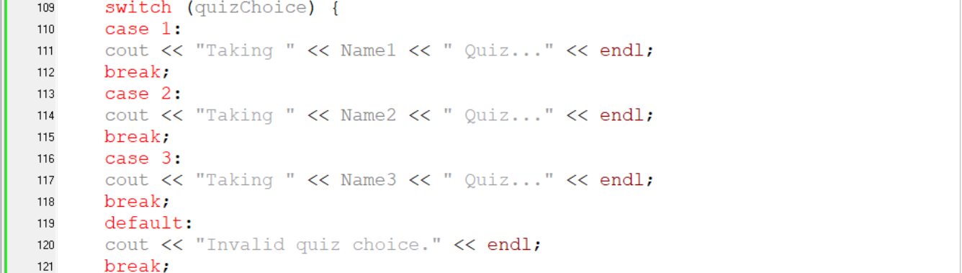

OOP code for this function

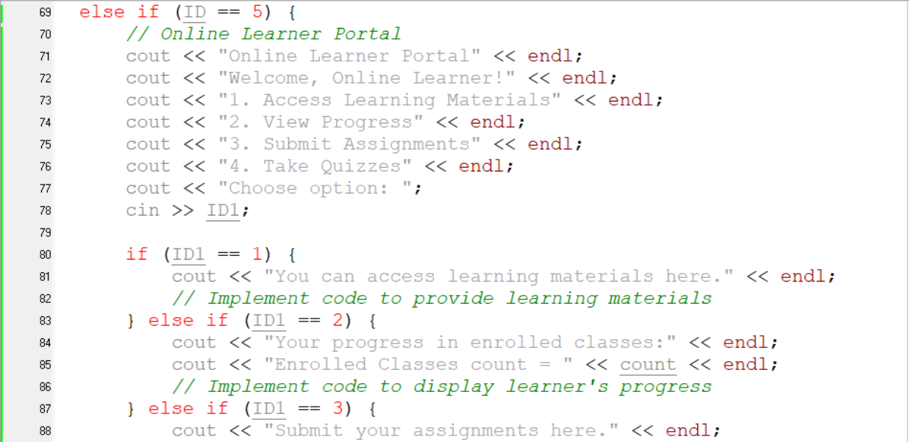

In the OOP style, the developer write the new system in the “function” keyword that located outside the main function. There is the different between PP and OOP. OO style also use “if” keyword to work each function with number. For number 4, this option has one more “if” keyword.

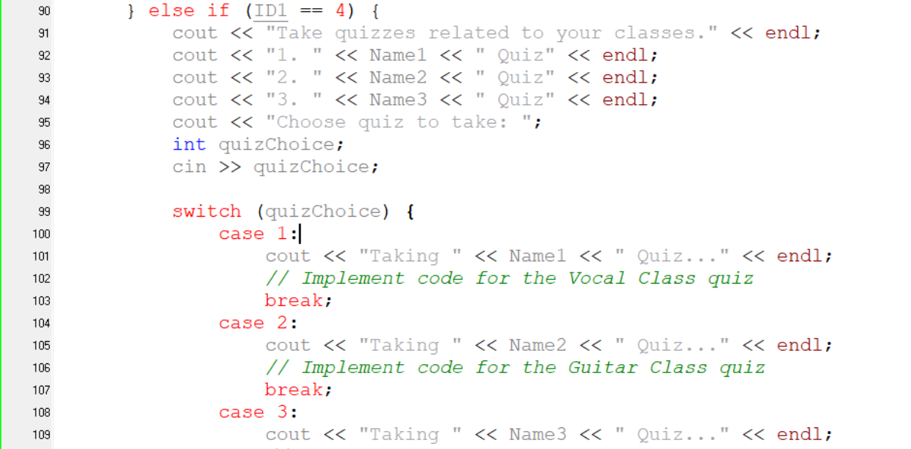



EDP code for this function

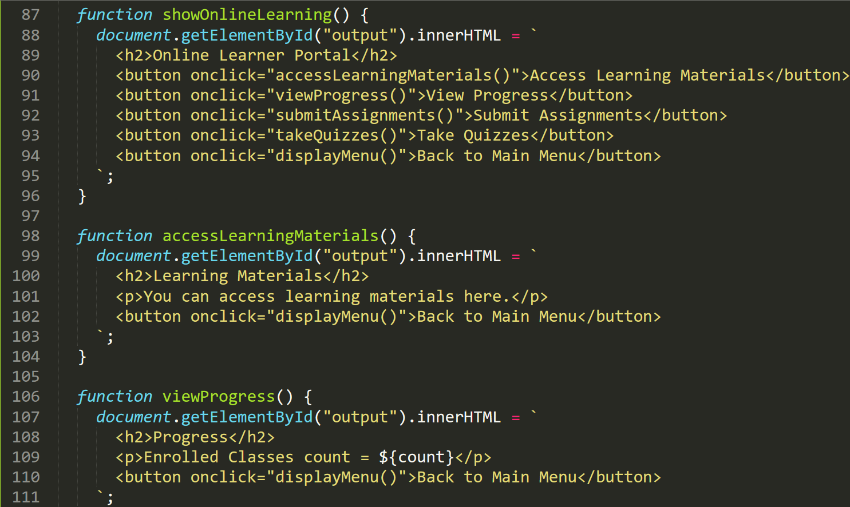

At the style of EDP, the developer use function keyword for showOlineLearing, accessLearingMaterials, viewProgress, submitAssignments, takeQuizzes. This new function is large to display. The common use keys are h2, button and etc.

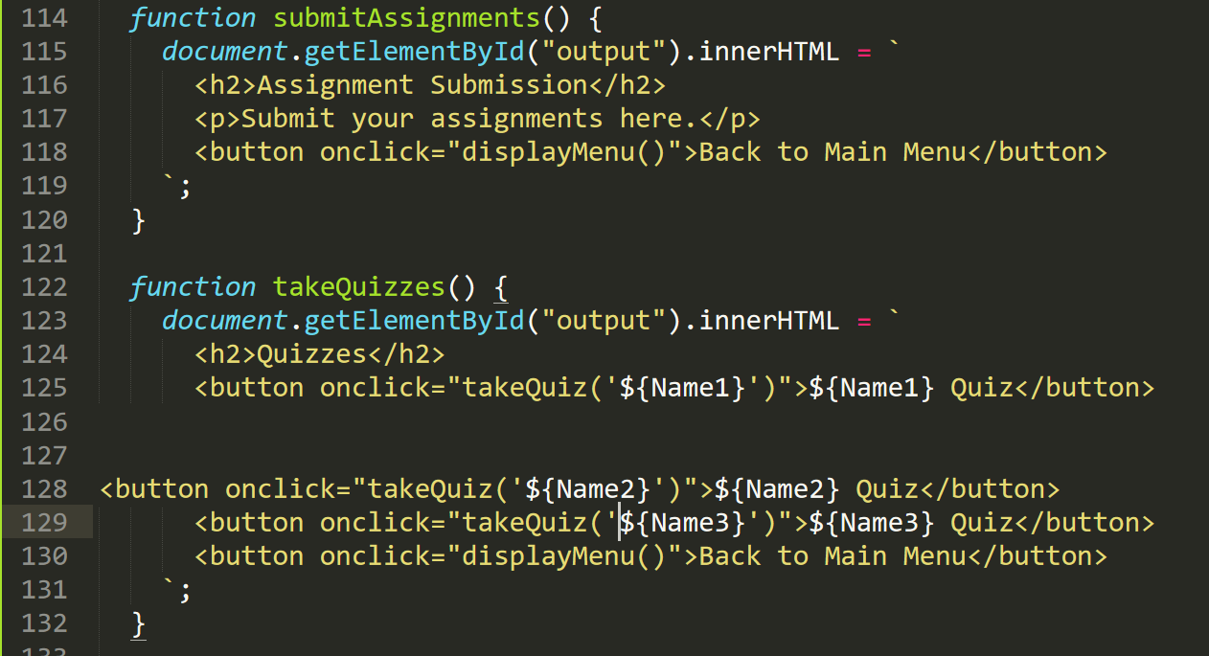

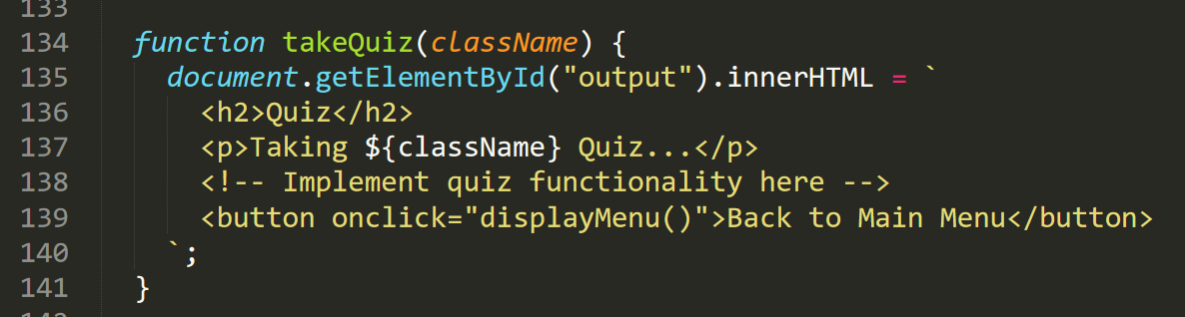

## Payment System

PP code for this function

In the PP style, the developer write the last function as Number 6 in “if” keyword. This is simple to use. For example, the user use number1, user will reach to payment. If not, the user will go back to main menu.

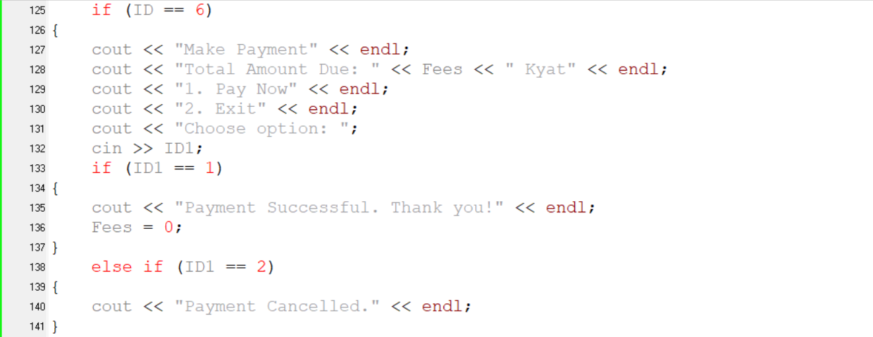

OOP code for this function

In the OOP style, the developer write the last function outside of the main function. In this function, the system will act as the payment for classes.

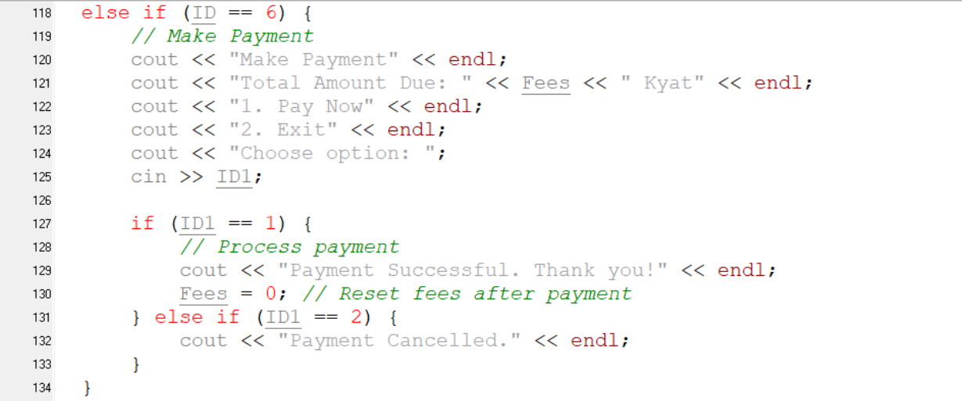

EDP code for this function

In the style of EDP, the developer use the function keyword for payment function. This function will help the user to pay the bill easily.S

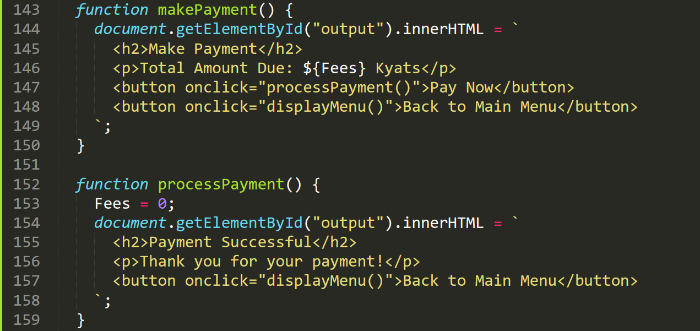

References

Gillis, A.S. (2023) *What is an algorithm?: TechTarget*, *WhatIs*. Available at: https://www.techtarget.com/whatis/definition/algorithm (Accessed: 30 March 2024).

GeeksforGeeks (2023) *Most important type of algorithms*, *GeeksforGeeks*. Available at: https://www.geeksforgeeks.org/most-important-type-of-algorithms/ (Accessed: 30 March 2024).

Gene Linetsky, M. (2024) *How to develop software (with pictures)*, *wikiHow*. Available at: https://www.wikihow.com/Develop-Software (Accessed: 31 March 2024).

Cocca, G. (2022) *Programming paradigms – paradigm examples for beginners*, *freeCodeCamp.org*. Available at: https://www.freecodecamp.org/news/an-introduction-to-programming-paradigms/ (Accessed: 06 April 2024).

Uttarwar, P. (2021) *Code review challenges faced by developers*, *Codegrip*. Available at: https://www.codegrip.tech/productivity/code-review-challenges-faced-by-developers/ (Accessed: 07 April 2024).

*Quicksort algorithm: An overview* (no date) *Built In*. Available at: https://builtin.com/articles/quicksort (Accessed: 08 April 2024).